Community Infrastructure Levy
Annual Report for North Nibley Parish Council
1st April 2020 – 31st March 2021
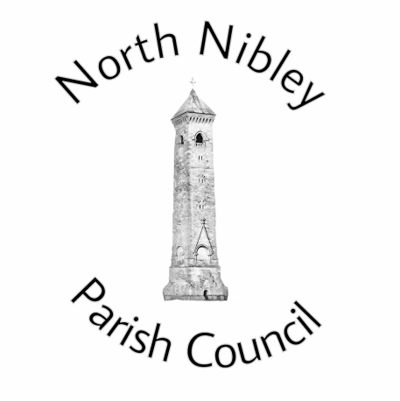
Delivered in partnership with
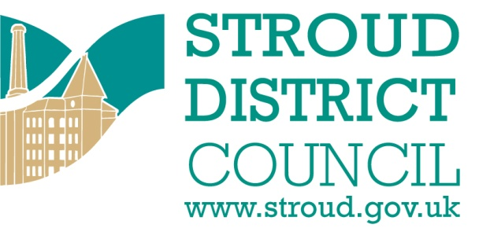
This report is published on 17th December 2021 by North Nibley Parish Council in accordance with the CIL Regulations 2010. Copies are made publically available on our Parish Council website ( www.northnibleyparishcouncil.org.uk ) and this has been formally reported to our local CIL Charging Authority Stroud District Council www.stroud.gov.uk.
Produced by: Mandy Rossiter (Clerk to North Nibley Parish Council)
Contact details: clerk@northnibleyparishcouncil.org.uk

CIL Neighbourhood Payment | Amount
CIL Receipts for April 2020 | £ 0.00
CIL Receipts for October 2020 | £0.00
Total CIL Income 2020/21 | £ 0.00
Balance carried over from previous financial year  (2019/20)* | £ 0.00
Total Available Budget for 2020/21  (this includes any CIL monies received in previous years which may have been retained) | £0.00
Total Expenditure 2020/21  (full details over page) | £0.00
Total Retained 2020/21  (to be carried over to 2021/22) | £0.00

* CIL receipts must not be kept on account for more than 5 years in line with legislative requirements.

Community Infrastructure Project 1:

Project name and location:

Brief description of works undertaken:

Date Project Completed:

Has the project been successful? How?

Total Project Costs: ......................................................  Summary of match funding secured: ..........................  Amount of CIL expenditure committed: ...................... | £  £  £

[Please copy and paste this table for each individual project you wish to report]

Further information on the Community Infrastructure Levy in the Stroud District
please visit the Planning pages at www.stroud.gov.uk

